The Percy and Jennie Hite Farm

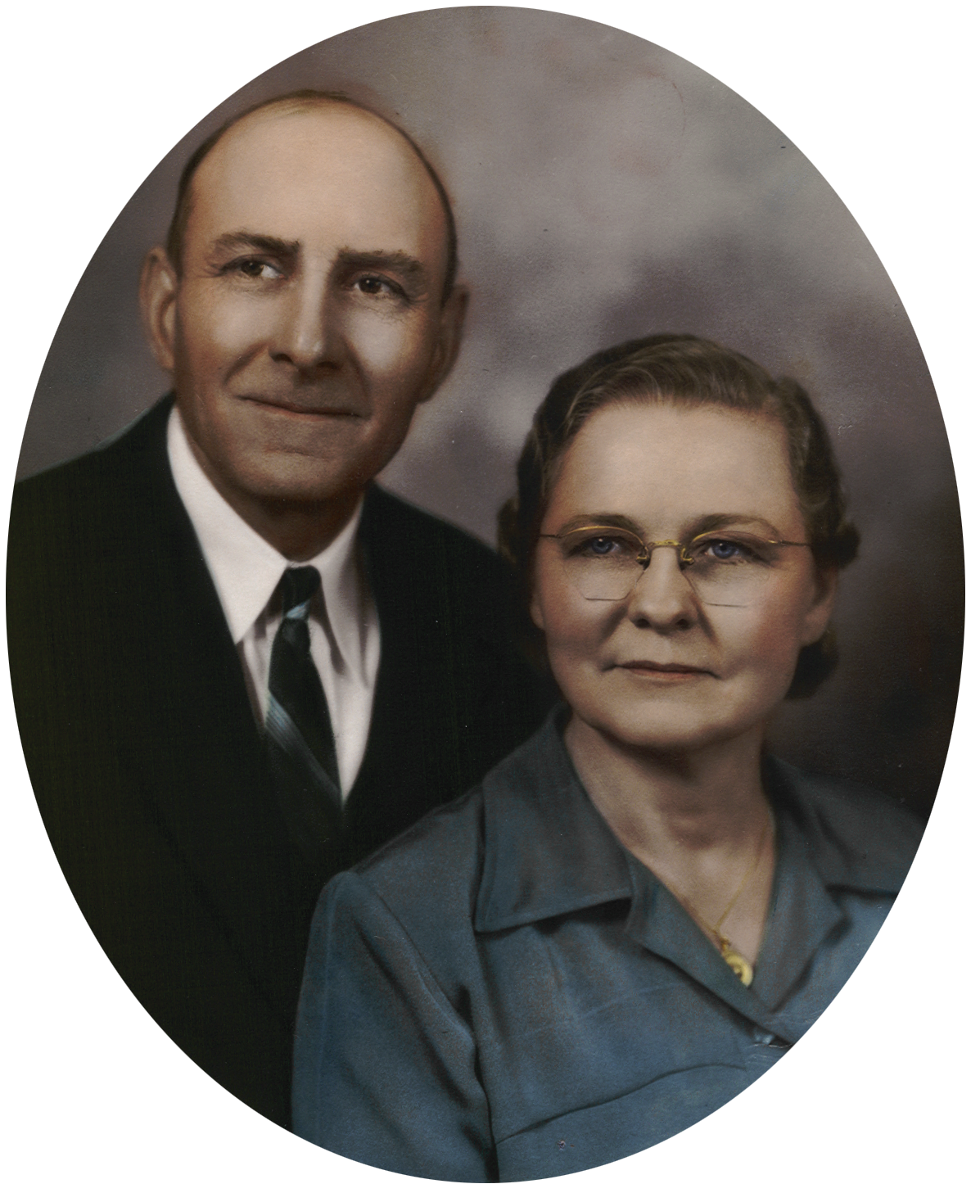

Percy and Jennie Johnson Hite were married on March 17, 1920 in Twin Falls, Idaho and rented what is now the Double H Ranch in Jerome from 1923 to 1945 before purchasing their own 20-acre farm two miles west of Jerome in 1945.

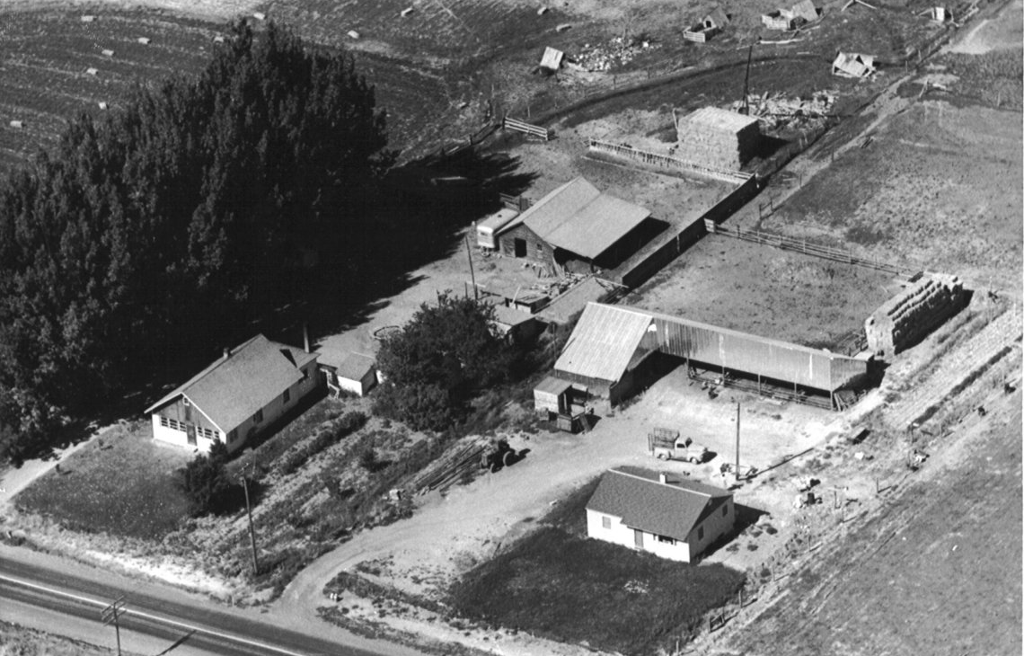

This aerial photograph of Percy and Jennie Hite’s farm was taken in the early 1950’s. There are actually two farms shown in this picture with the property line between them running diagonally from the left front to the right back of the picture. The Hite’s farm house is the larger house on the left. Starting counter-clockwise behind the house is a merry-go-round that was built by Gene Hite, a one-car garage and old chicken house that are obscured by trees, a cistern for holding water, and the large barn and shed next to a trailer house. There is also a new chicken house and granary that are both largely obscured in the shadows of the large cottonwood trees on the left of the picture. Percy and Jennie Hite purchased this 20-acre farm in 1945 and remained there until retiring in 1966.

The George and Dora Silver Farm

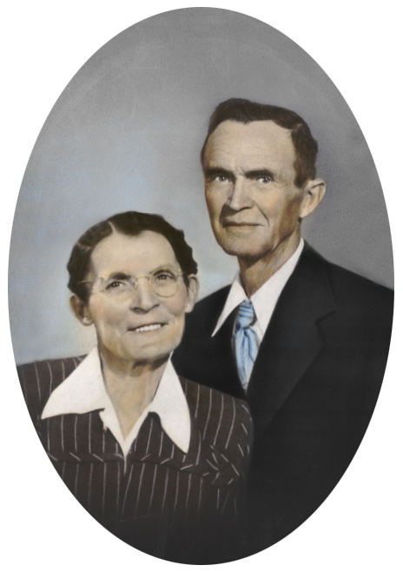

George and Dora Chess Silver were married on May 23, 1915 and moved to Jerome from Hailey, Idaho in November of 1937 where they purchased what is now the Silver Nugget Mule Ranch on the Golf Course Road.

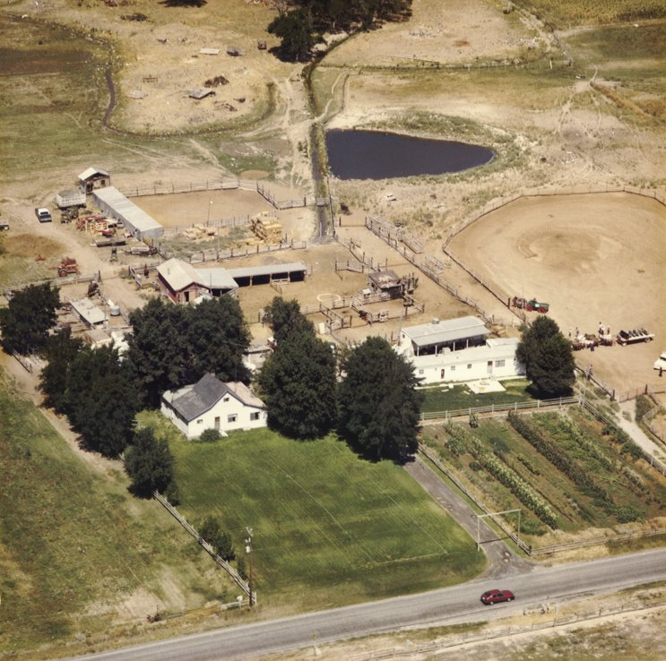

This aerial photograph of George and Dora Silver’s farm was probably taken in the 1970’s some years after they owned the farm from November of 1937 to November of 1957. When George and Dora Silver retired from farming in 1957, they sold the farm to George Jr. and Joyce Silver who are farming the land to this day. While trees obscure many of the smaller out buildings, this picture shows the original farm house in the center of the lawn and the barn and stock sheds behind the house. The trailer house on the right of the picture was actually moved there some time after the elder Silvers left in 1957. George and Dora Silver had eight children.

The Gerald and Dolly Hite Farm

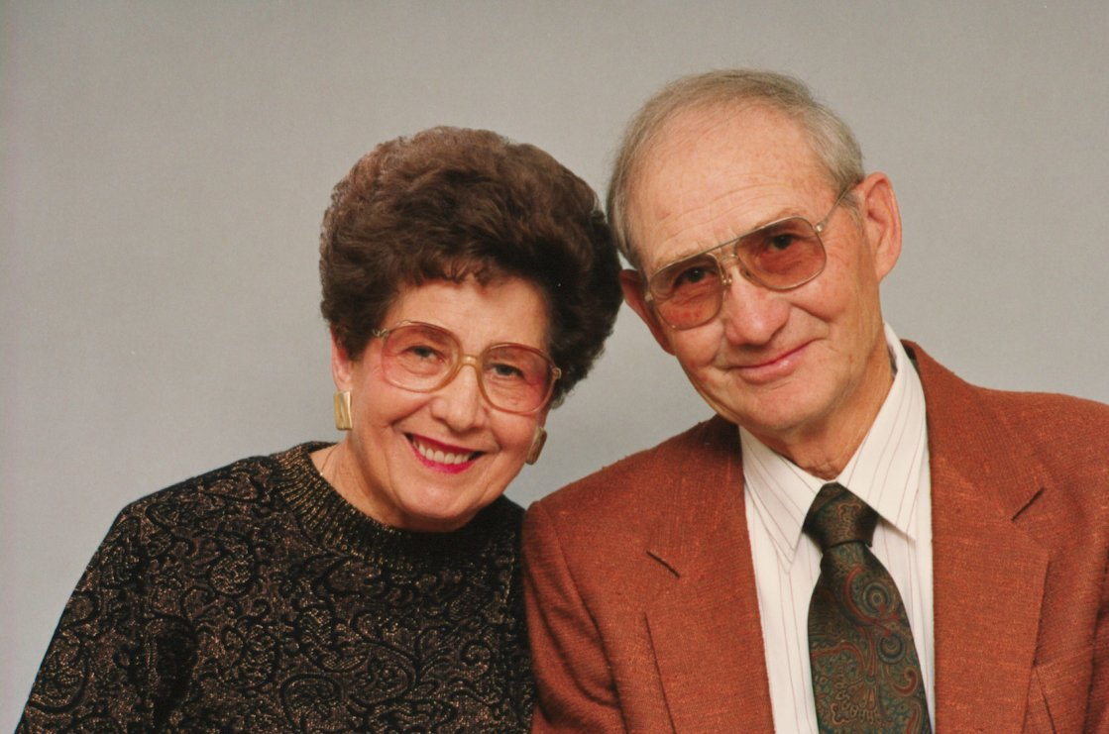

Gerald and Dolly Snyder Hite were married on December 14, 1940 and purchased an 80-acre farm on the Bob Barton Road in 1941.

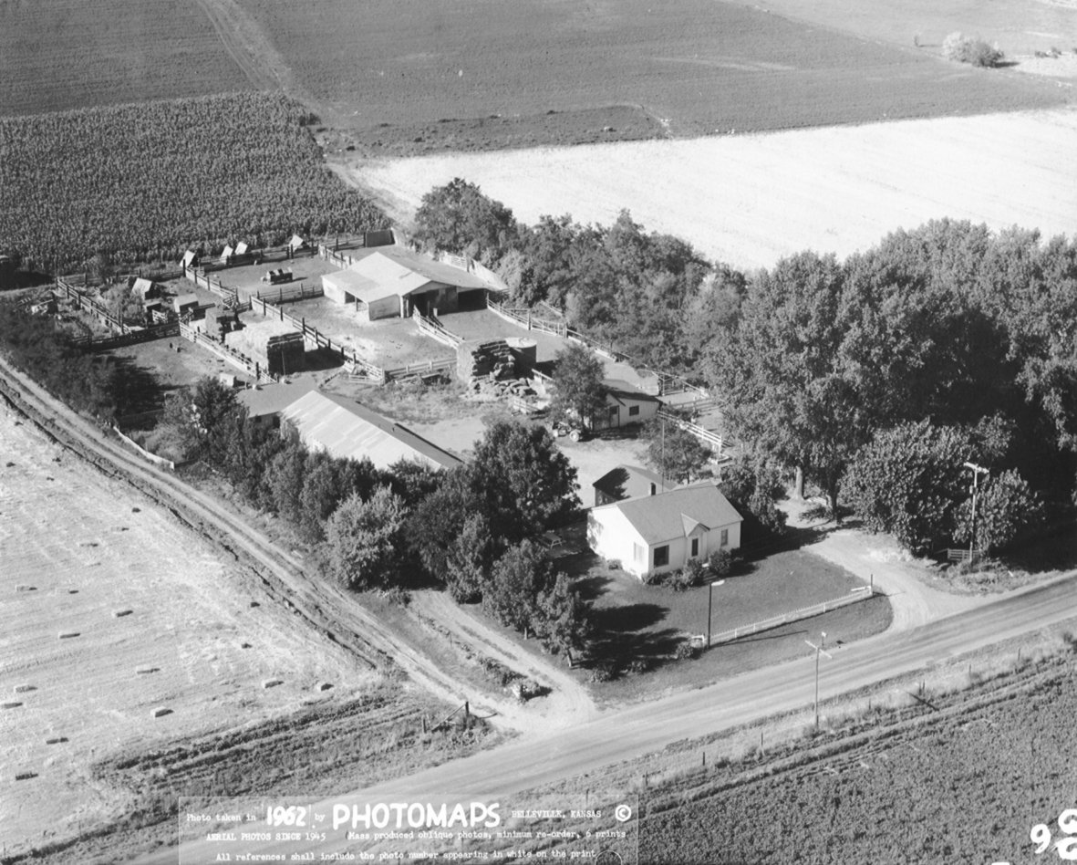

This aerial photograph of Gerald and Dolly Hite’s farm was taken in the summer of 1962. After purchasing the farm in 1941, the couple built the farm house which faces the road, the large metal building on the left which houses the garage, machine shop, and granaries, and the small barn directly behind the house. The older rock barn in the rear of the complex is surrounded by the corrals. The original farm house was located amongst the trees on the right of the picture. Gerald and Dolly Hite have two grown children who were raised on the farm, Sheryl and Marilyn. The couple finally sold the farmhouse and remaining acreage of the farm in 1998.

The J.G. and Wanda Silver Farm

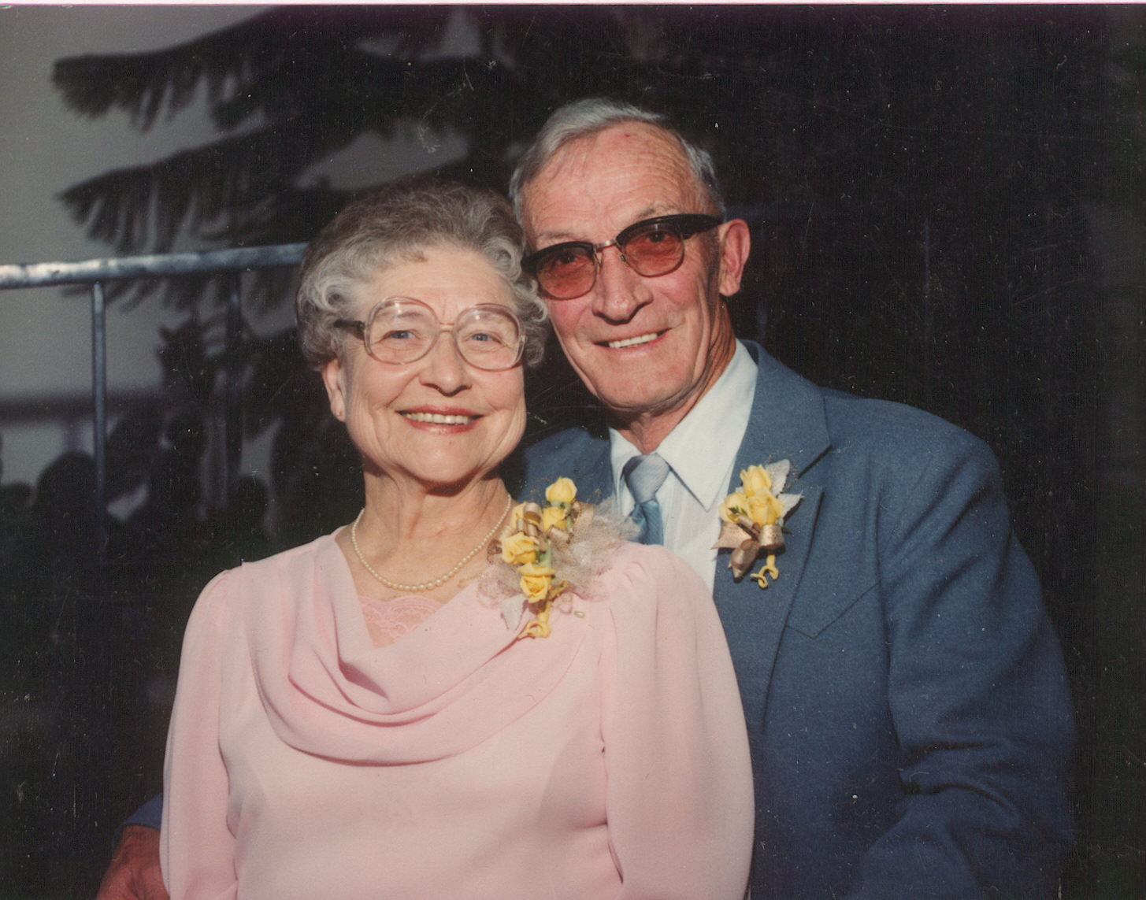

Jesse George (J.G.) and Wanda Ball Silver were married on July 5, 1938 in Shoshone, Idaho and farmed near Jerome for several years including cultivating the farm on George and Dora Silver’s home place for two years.

This aerial photograph of George and Dora Silver’s farm was probably taken in the 1970’s some years after they owned the farm from November of 1937 to November of 1957. The elder Silvers rented the home acreage to J.G. and Wanda Silver for two years while George Silver was working as a carpenter out of the area. During the 1940’s, the only structures that existed were the original farmhouse shown on the left, the barn and accompanying corrals, and the garage that is behind the canopy of trees behind the house in this picture. George Silver Sr. built both the barn and the garage on the property that are still standing today.

The Raymond and Florene Silver Farm

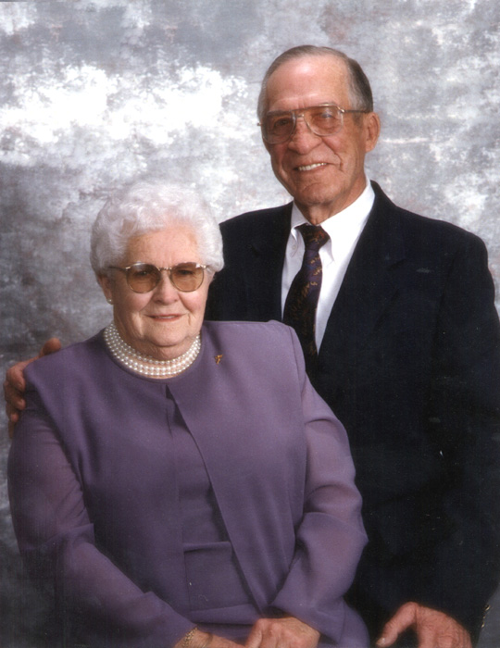

Wallace Raymond and Florene Bishop Silver were married in Jerome on November 29, 1938. On October 31, 1941, the couple purchased a 40-acre farm located across the road from the Jerome Country Club and adjacent to the 80-acre farm owned by Ray’s parents, George Sr. and Dora Silver.

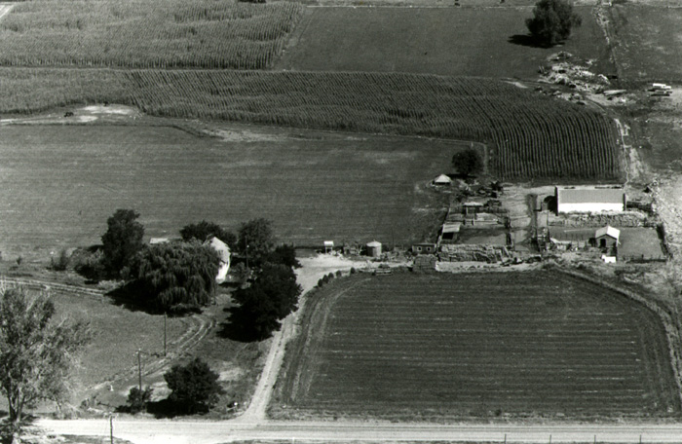

This aerial photograph of Ray and Flo Silver’s farm taken during the 1970’s shows the long lane leading to the acreage from the Golf Course Road south of Jerome. The lane leads to the original farmhouse on the left that is surrounded by shade trees. The silo, haystack, barn, shed, and stock pens can be seen on the right of the picture. Ray and Flo Silver have four grown children who were raised on the farm, Lary, Gary, Wilma, and Norma.

The George Jr. and Joyce Silver Farm

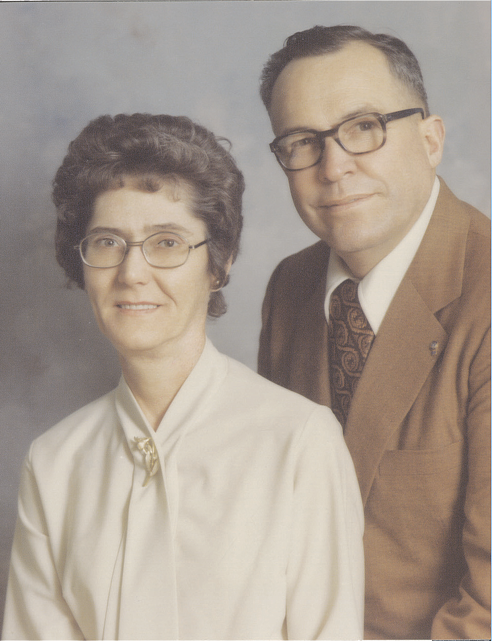

George Jr. and Joyce Wall Silver were married in Jerome on April 12, 1950 and purchased what is now the Silver Nugget Mule Ranch in November of 1957 from George Jr.’s parents.

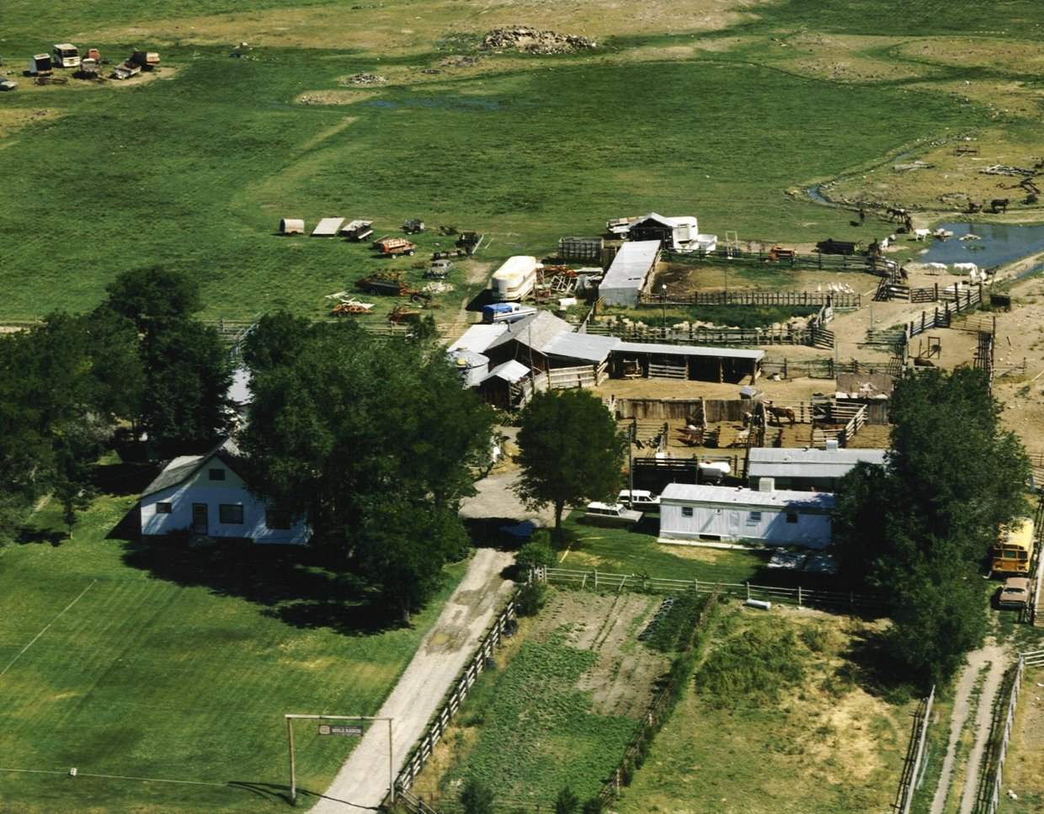

This aerial photograph of George Jr. and Joyce Silver’s farm shows the gated entrance leading to the Silver Nugget Mule Ranch. The lane leads to the original farm house on the left shaded by trees. The barn, silo, and stock sheds can be seen in the center of the picture. Some of the livestock can also be seen in the small pond on the right of the picture. George Jr. and Joyce Silver have three grown children who were raised on the farm, George III, Susan, and Kathi.

The Bart and Delores Silver Farm

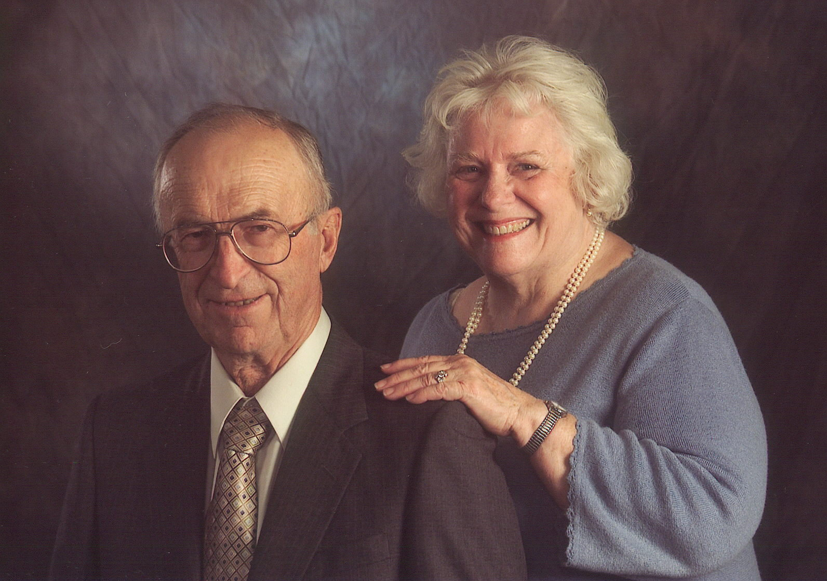

Bart and Delores Durfee Silver were married in Twin Falls, Idaho on July 7, 1955. In 1962 the couple purchased a 20-acre farm five and one-half miles south and one mile east of Jerome. In the summer of 1966, they moved into their new house on the acreage that was constructed by Gene Hite.

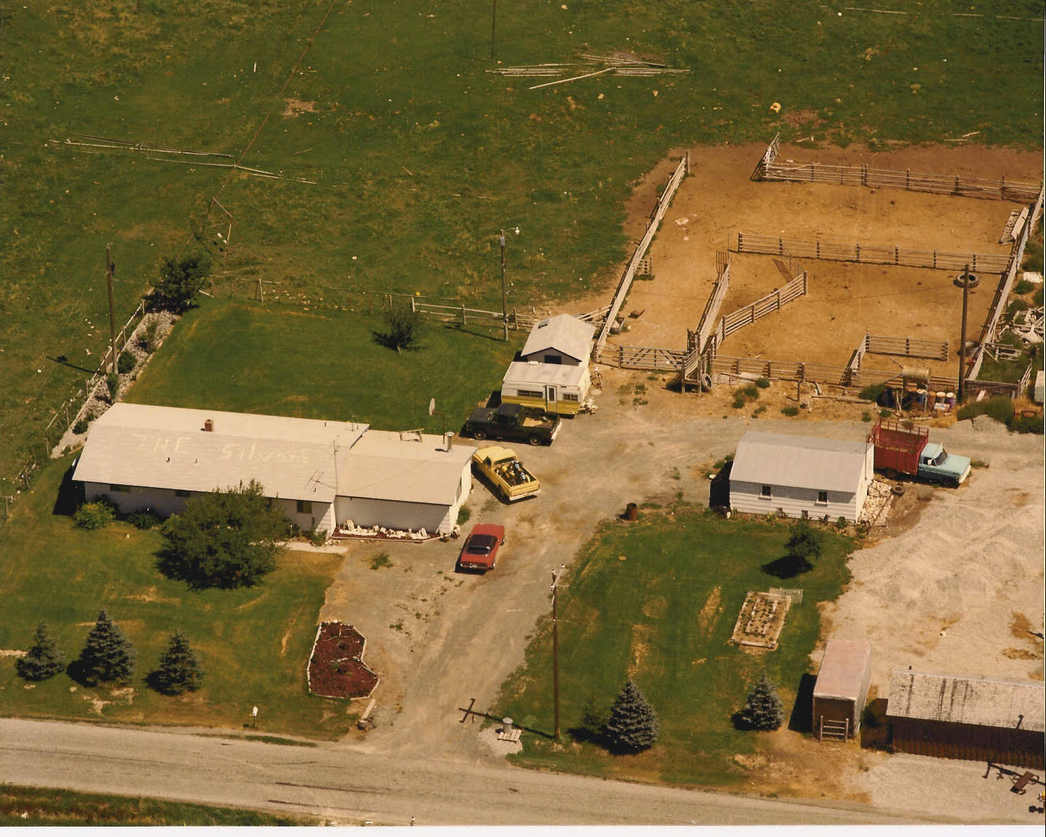

This aerial photograph of Bart and Delo Silver’s farm was taken in the early-1970’s and shows the original farmhouse on the left along with the family room addition on the right of the home. The garage can be seen on the right side of the photo and the barn is the small structure shown on the left bottom corner of the picture. The couple’s sons, Bret and Mike, spray painted the words “The Silver’s” on the roof of the house sometime in the early 1970’s. The corrals can be seen in the upper right portion of the photograph.

The Gene and Sylvia Hite Farm

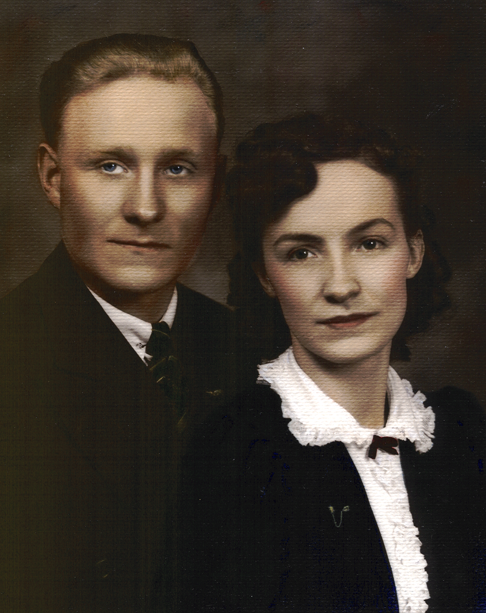

Gene and Sylvia Silver Hite were married on July 7, 1941 and started farming on what is now the Double H Ranch in 1945.

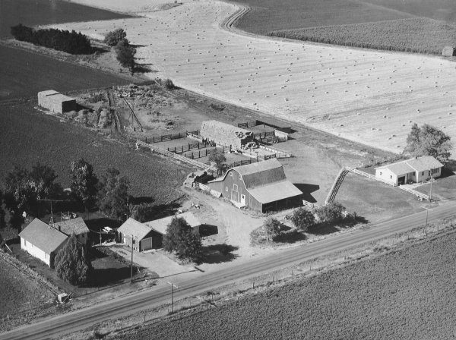

This aerial photograph of Gene and Sylvia Hite’s farm was taken in the summer of 1962. The large barn on the property stands next to the adjoining corrals, stock shed, and haystacks. The original farm house is located on the left while the tenant house, which was built by Gene Hite, is located on the right. Gene and Sylvia Hite have three grown children who were raised on the farm, Gene Jr., Nancy, and Don. The field full of hay bales in the back portion of this picture is part of Gerald and Dolly Hite’s adjoining farm.

The Gene and Sylvia Hite Farm

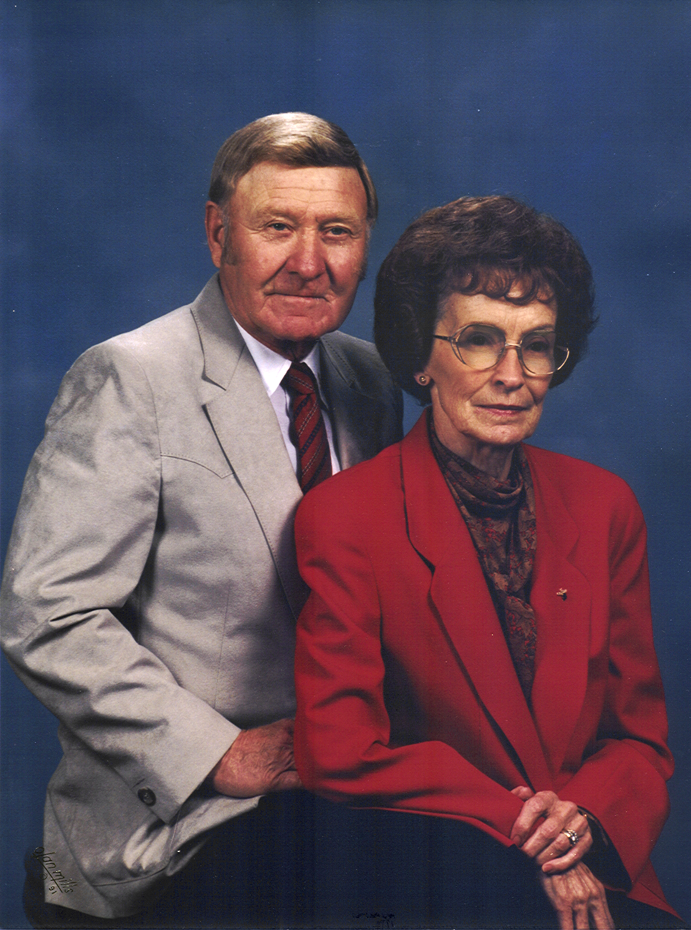

Gene and Sylvia Silver Hite celebrated their 50th Wedding Anniversary on August 3, 1991 on the Double H Ranch southwest of Jerome.

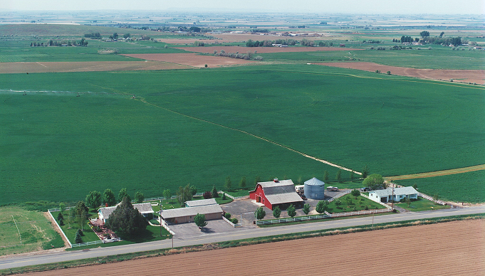

This aerial photograph of Gene and Sylvia Hite’s farm was taken about three years after their 50th Wedding Anniversary on May 14, 1994 and shows many of the continuous improvements on the farm that have occurred over the years. This picture shows the large metal silo that was added in 1982 as well as the large number of trees and lawn areas that were added around the farm buildings during the last quarter of the 20th century. The quarter-mile radius pivot that was added in 1976 and used by both Gene and Gerald Hite’s farms can be seen spraying water in the left rear portion of the picture.

